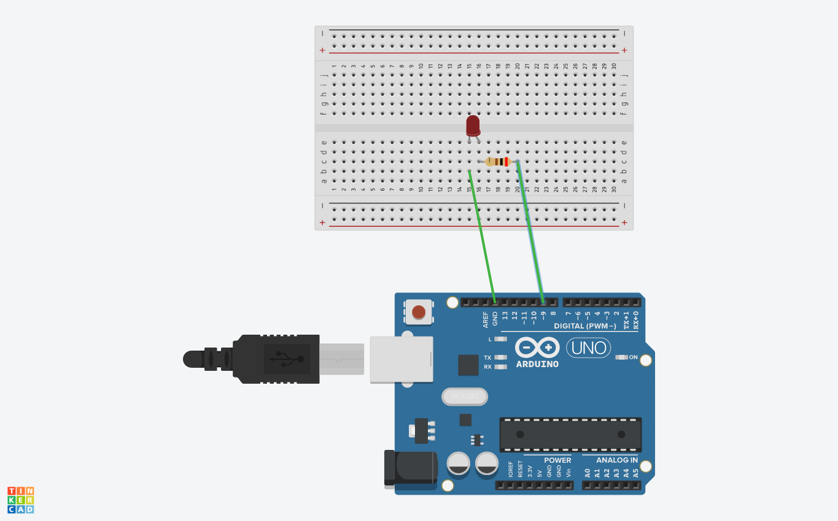**EXPERIMENT 1- LED Flasher**

**Theory-**

**Concept Used-** In this experiment

1. The concept of ohms Law is used in the circuit of this experiment.
2. The circuit must be properly closed with all the connections proper.

**Learning and observations-** If we complete the circuit without any error we notice that the LED starts glowing and glow with flashing the light.

**PROBLEMS AND TROUBLESHOOTING:**

We have to take care whether the board is connected properly with Arduino\UNO or not and take care of the selection of port and parts of circuit.

**PRECAUTIONS:**

1. While connecting led with breadboard we should take care whether the terminals of led are properly connected or not.
2. Install the wires properly with LED, breadboard and Arduino board.

**LEARNING OUTCOMES:**

In this experiment, we get to know about the blinking of LED with the help of Arduino and breadboard and by coding we can blink the LED according to our need and in any pattern.